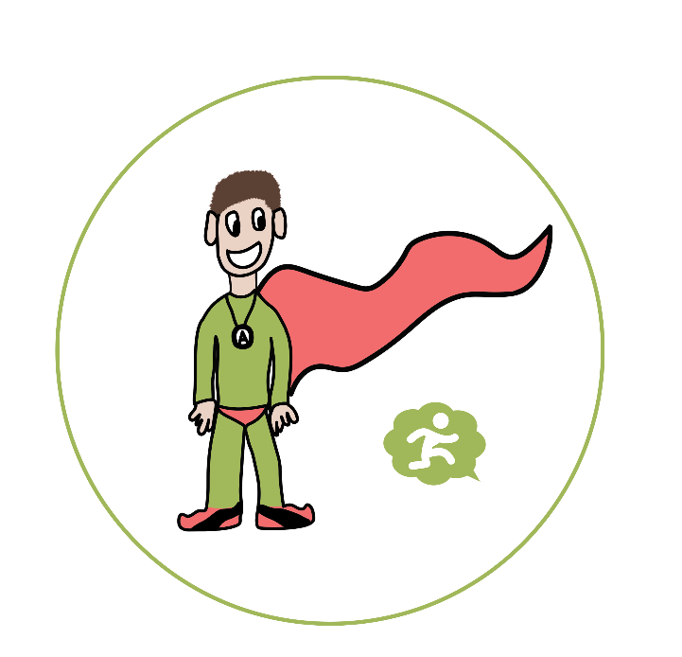

*Agile Alex*

*Analysing Owl*



*Empathetic Emily*

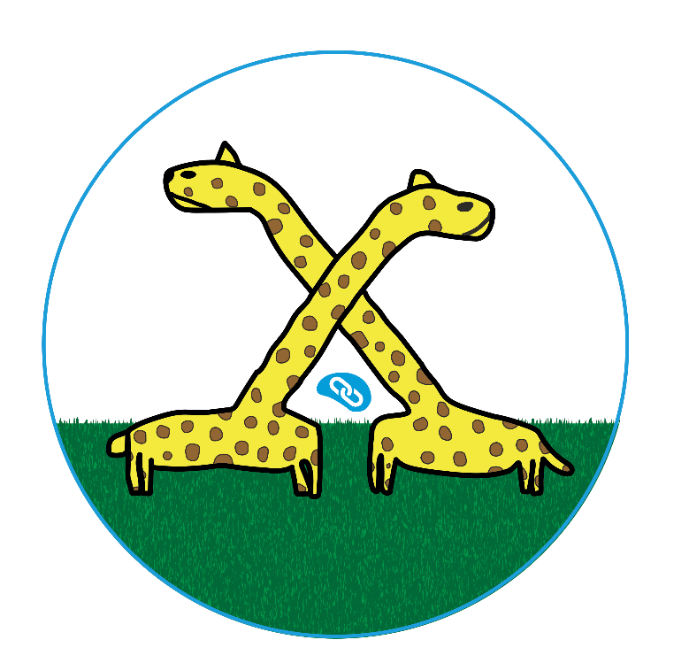

*Linking Giraffes*

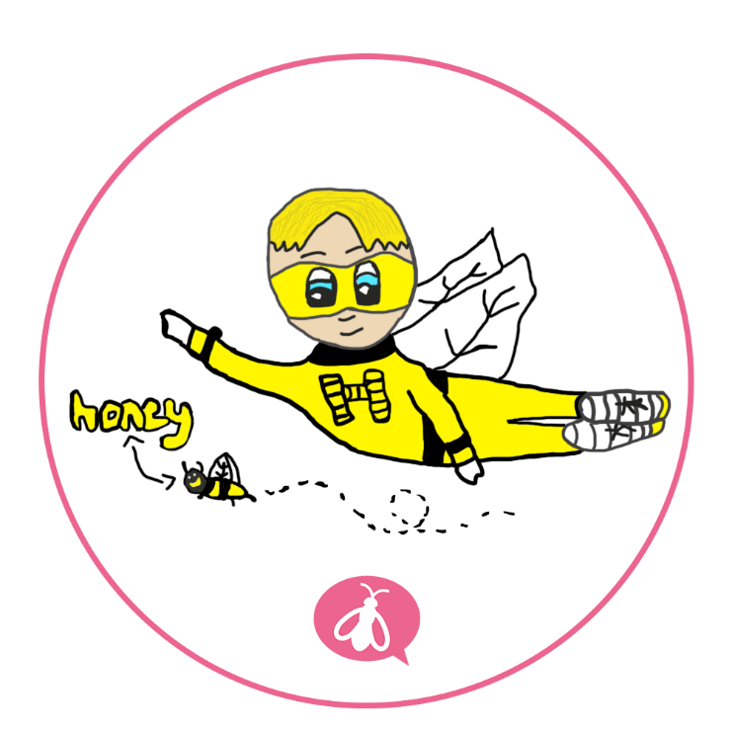

*Hard working Harold*

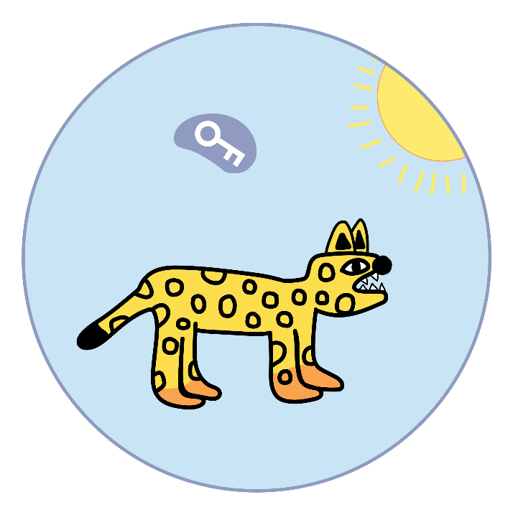

*Neta the Cheeta (realising)*

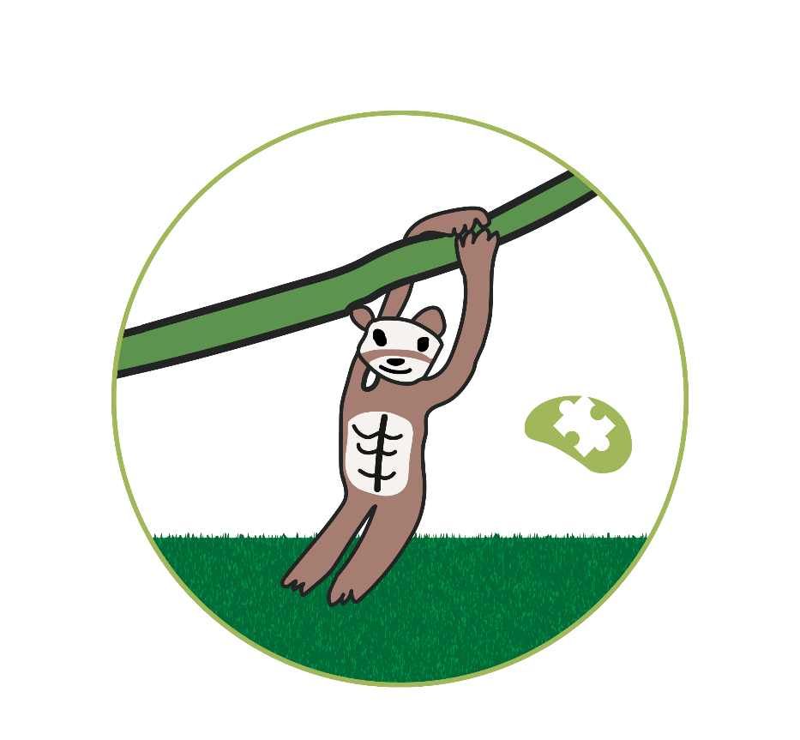

*Mark the meta-thinking monkey*

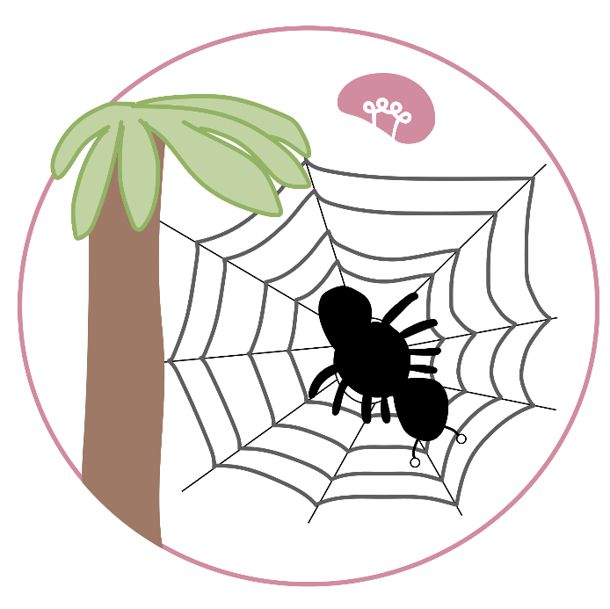

*Sam the creative spider*