Housepoint log: April 2024:
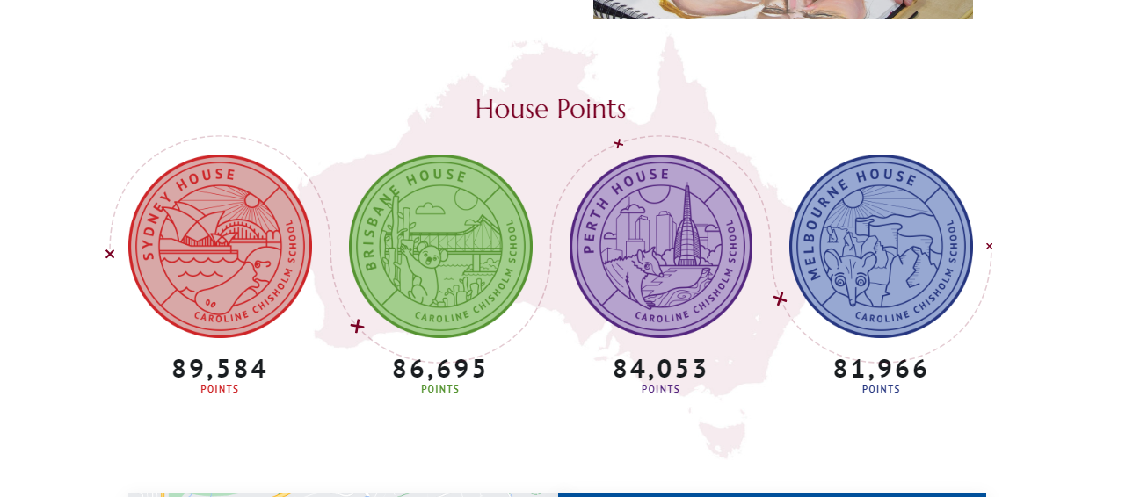
Progress dashboard – records individual, class and year group achievement:
