**HPL Day Booklet – Enterprise**

* **Throughout the day you will be completing a series of enterprise-related tasks and challenges both independently and as part of a team.**
* **These are designed to enable you to develop your HPL skills giving you the opportunity to show creativity, intellectual playfulness, confidence and much more.**
* **Your day is going to be split into a series of business events, meetings or conferences. For example, lesson 1 will become your first business meeting of the day.**
* **You will have the opportunity to work indiviually and as part of a team.**
* **At the start of each meeting, you need to set yourself a HPL goal to work towards in that meeting.**
* **This should relate to the task you are completing in each business meeting.**

**Example Goal - I am going to develop my analytical skills to help me decide which skills are the best for an entrepreneur.**

* **At the end of each business meeting you need to evaluate how successful you have been using a Red, Amber, Green System.**
* **Red – No Amber – Partially Green - Yes**
* **Use the HPL checklist on the next two pages to to help you set your goals.**

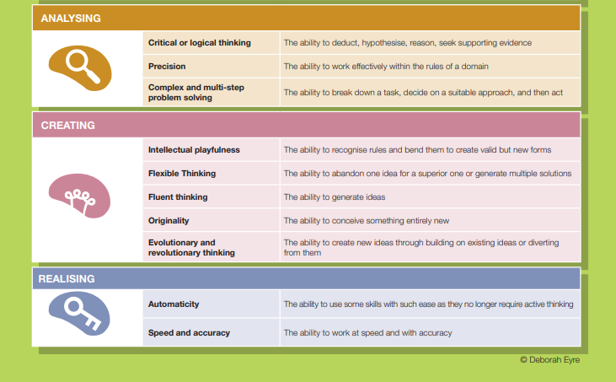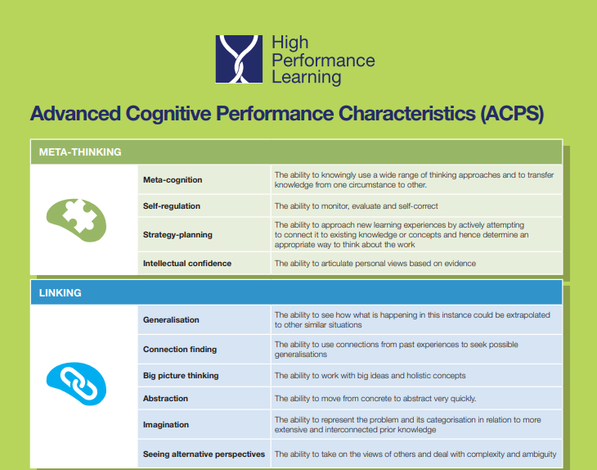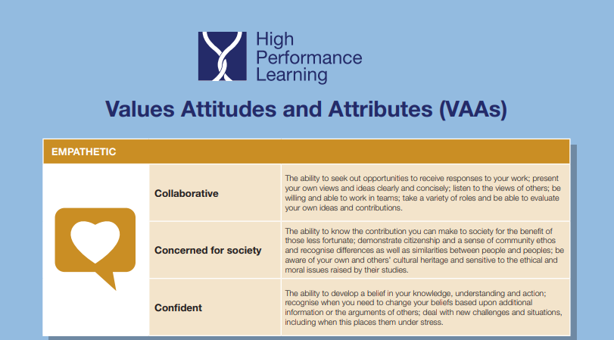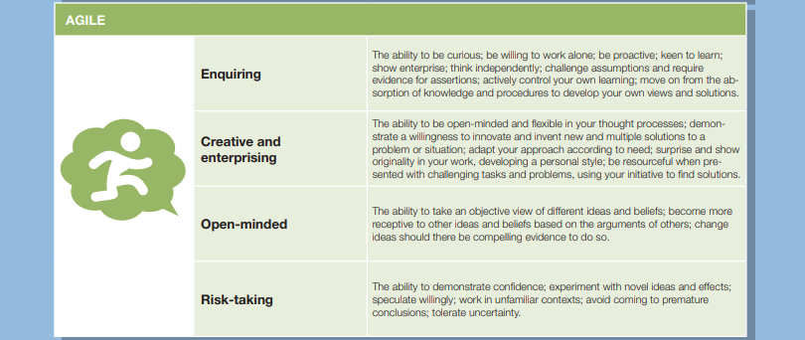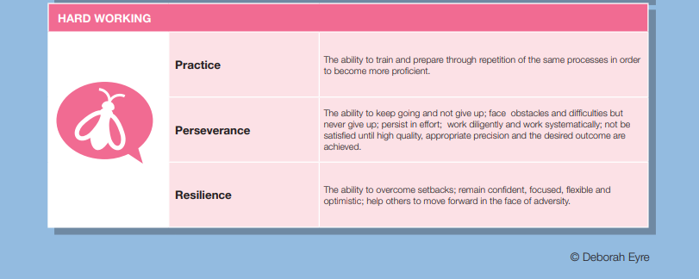

**Business Meeting One – Characteristics of an Entrepreneur**

In this meeting we will be looking at the skills an entrepreneur might need to be successful.

**Example HPL Goal:** I am going to develop my analytical skills to help me understand the skills needed to be a successful entrepreneur.

My HPL goal in meeting one is: ………………………………………………………………………………………………………………………………………………………………………………………………………………………………………………………………………………………………………………………………..

Characteristics of an Entrepreneur



Name the entrepreneur!

1.

2.

3.

4.

5.

Ranking Entrepreneurial Skills

Most Important Skill

Least Important Skill

Meeting One Conclusion - Did I meet my goal?

RED AMBER GREEN

**Business Meeting Two – What is a Community?**

In this meeting we will be looking at what a community is, the benefits of being part of a community and you will begin to create ideas for your product/service.

**Example HPL Goal:** I am going to develop my original thinking skills to help me create a new and exciting service that will benefit my local community.

My HPL goal in meeting two is: ………………………………………………………………………………………………………………………………………………………………………………………………………………………………………………………………………………………………………………………………..

Social Objectives

Community

**Your challenge – Your local council have tasked you with creating a product or service to benefit the local community.**

You need to be agile learners and take risks when selecting your top product or service.

You also need to be confident and have belief in your decision that you have chosen the best ideas, even if your business partners have chosen another idea.

Use this space to be creative and think of lots of good ideas that would benefit your community!

Meeting One Conclusion – Did I meet my goal?

RED AMBER GREEN

**Business Meeting Three – Creating a Brand**

In this meeting we will be looking at what a brand is and creating your own brand based upon the product/service you have come up with.

**Example HPL goal:** I am going to develop my risk taking by being confident in the work that I produce.

My HPL goal in meeting three is: ………………………………………………………………………………………………………………………………………………………………………………………………………………………………………………………………………………………………………………………………..

Use this space to be creative to create your brand!

**Meeting Four – Promoting Teamwork**

In this meeting we will be aiming to improve the way in which we work as a team. You will be working with your business partners to ensure your team works well together.

**Example HPL goal:** I want to develop my collaboration skills so I can work well in my team to meet the needs of the task.

My HPL goal in meeting three is: ………………………………………………………………………………………………………………………………………………………………………………………………………………………………………………………………………………………………………………………………..

Use this space to plan your groups team building activity.

Meeting One Conclusion – Did I meet my goal?

RED AMBER GREEN

**Meeting Five – Continue creating your Brand**

**In this meeting you will continue to develop your brand.**

**Example HPL Goal:** I am going to develop my perseverance to continue to develop my brand for the service I have thought about.

My HPL goal in meeting three is: ………………………………………………………………………………………………………………………………………………………………………………………………………………………………………………………………………………………………………………………………..

Social Media Posts  
 Celebrity Endorsement or Celebrity Connections?   
Sponsorship Opportunities  
Adverts (TV Storyboard, Radio Script, Billboard)  
Logo  
Strap Line

**My brands Mission Statement:** ………………………………………………………………………………………………………………………………………………………………………………………………………………………………………………………………………………………………………………………………………………………………………………………………………..………………………………………………………………………………………………………………………………………………………………………………………………………………………………………………..

**Meeting Six – Evaluation**

In your final business meeting, we will be evaluating your enterprise day. You will be completing some peer and self-evaluation.

**Example HPL goal:** I want to develop my self-regulation skills in order to give useful feedback to my peers and to help me know where I could improve.

My HPL goal in meeting three is: ………………………………………………………………………………………………………………………………………………………………………………………………………………………………………………………………………………………………………………………………..

**WWW** (What went well) - Good points that we like about the work our business partner has accomplished.

**EBI** (Even better if) – Feedback we think would help our business partner improve their product/service.

Feedback to business partner 1

WWW:…………………………………………………………………………………………………………………………………………………………………………………………………………………………………………………………………………………………………………………………………………………………………….

WWW:…………………………………………………………………………………………………………………………………………………………………………………………………………………………………………………………………………………………………………………………………………………………………….

EBI:………………………………………………………………………………………………………………………………………………………………………………………………………………………………………………………………………………………………………………………………………………………………………….

Feedback to business partner 2

WWW:…………………………………………………………………………………………………………………………………………………………………………………………………………………………………………………………………………………………………………………………………………………………………….

WWW:…………………………………………………………………………………………………………………………………………………………………………………………………………………………………………………………………………………………………………………………………………………………………….

EBI:………………………………………………………………………………………………………………………………………………………………………………………………………………………………………………………………………………………………………………………………………………………………………….

Feedback to business partner 3

WWW:…………………………………………………………………………………………………………………………………………………………………………………………………………………………………………………………………………………………………………………………………………………………………….

WWW:…………………………………………………………………………………………………………………………………………………………………………………………………………………………………………………………………………………………………………………………………………………………………….

EBI:………………………………………………………………………………………………………………………………………………………………………………………………………………………………………………………………………………………………………………………………………………………………………….

Self-Evaluation

What have you done well today?

……………………………………………………………………………………………………………………………………………………………………………………………………………………………………………………………………………………………………………………………………………………………………………….

…………………………………………………………………………………………………………………………………………………………………………………………………………………………………………………….

What could you continue to do to improve your product/service further?

…………………………………………………………………………………………………………………………………………………………………………………………………………………………………………………….…………………………………………………………………………………………………………………………………………………………………………………………………………………………………………………….

Finally, please complete the Microsoft forms quiz. This has been shared on your year group Teams page.

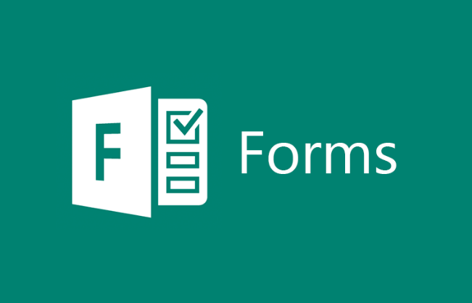

**Going for a Promotion! Can you answer the questions below?**

* When creating a business is it more important to make a profit or have a purpose?
* Imagine we are 5 years in the future and you have got your product/service up and running. What are the local community saying about your business? Could you write a newspaper article and headline?
* What will the future needs of your customers be in 10 years time?
* How do you keep your motivation levels high when working on a project that takes months to complete?
* If you had to hire someone to work in your business what qualities would you look for and why?
* Create 5 questions that you would want to ask someone if they applied for a job with your business. Could you write a model answer to your questions?