Year 1 – Analysing and Meta-Thinking
We have been using our meta-thinking and analysing in our phonics. The children had to read and blend words containing our new diagraphs for the week and then sort them into the right column depending on what diagraph the word contained. Once we read each word the children had to use their existing vocabulary to also decide if a word was real or an alien word (pseudo words). This will also help the children gain greater automaticity in their reading.
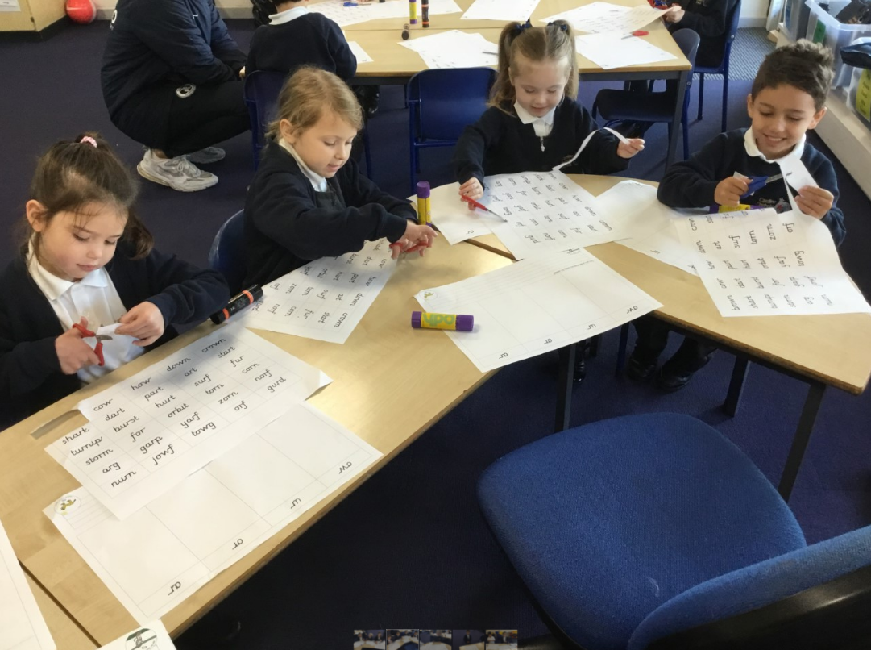

KS2 – Analysing – Critical and Logical Thinking
In Geography this week, the Year 2 children followed a line of enquiry to find out which countries belong in each of the continents... and which continent has no countries at all and why is this? Like Ana the Analysing Owl, they looked closely at the atlases to gain a deeper understanding. The children practised their recall skills later in the week, working like Neeta the Cheetah to quickly recall their knowledge of countries and continents.
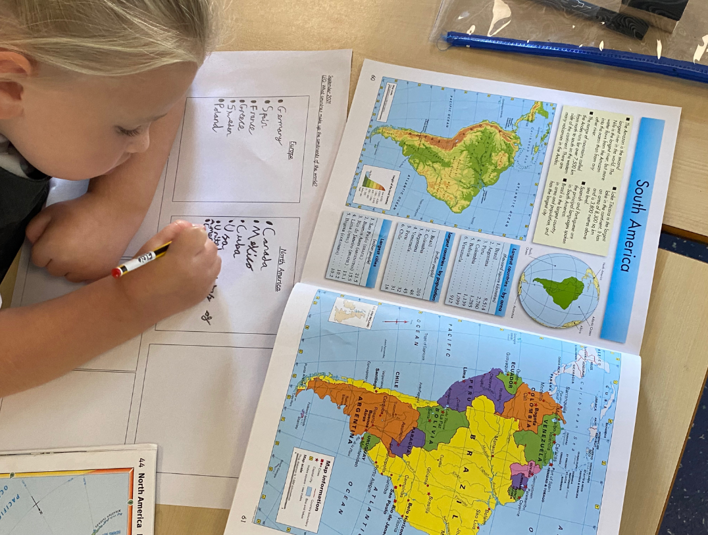

Year 10 – Risk Taking and Precision
Just wanted to show a task I applied in GCSE PE that worked really well.

After a brief introduction to muscle fibres I then set a task for pupils to be independent learners and showcase some creativity but also Agile thinking - taking some risk with their research and presentation

The three pupils above have different megs and it was interesting to see how they all processed the task differently.

Dennis at the top went basic but precise with a clear and effective poster.

The most pleasing was Loki bottom left who academically struggles and has learning needs that require constant support. The task allowed him to showcase his artistic strengths along with some good facts on muscle fibres. Hopefully tasks like this build his confidence and allow him to retain information he might normally struggle to process.

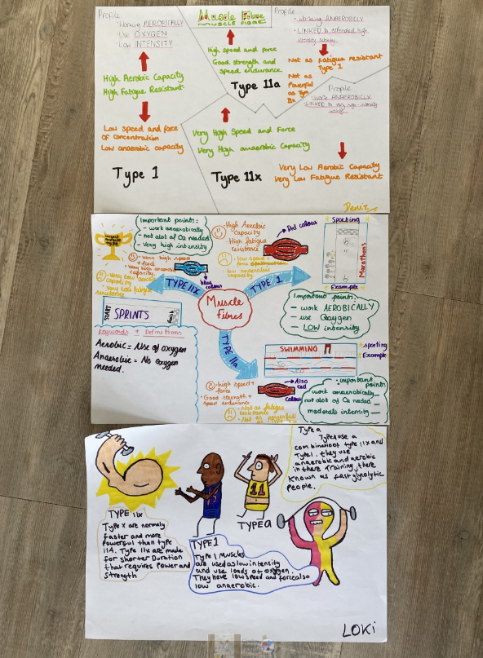

Year 12 & 13
Here is a presentation for Yr12/13 to help them to ANALYSE different types of plastic processing methods, LINK to prior knowledge and use META-COGNITION to think about how the content will be examined. Feel free to watch the linked videos
