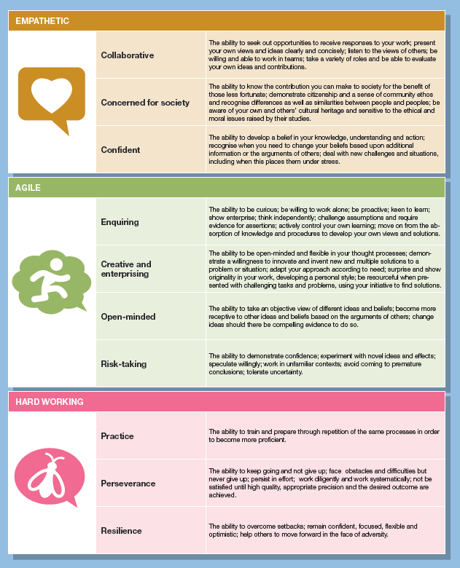

Values, Attitudes & Attributes – How learners behave
Empathetic – Links to EYFS Characteristics of Learning
 | Collaborative | Playing and Exploring - Acting out experiences with other people.
 | Concerned for society | Playing & Exploring – Showing curiosity about objects, events and people.
 | Confident | Playing & Exploring – Taking on a role in their play.
 |  | Playing & Exploring – Initiating activities, seeking challenge, showing a can-do attitude, taking a risk, learning by trial and error.
 |  | Active Learning – Persisting when challenges occur, bouncing back after difficulties.
Agile - Links to EYFS Characteristics of Learning
 | Enquiring | Playing & Exploring – Seeking challenge.
 | Creative and enterprising | Creating and Thinking Critically – Thinking of ideas.
 |  | Creating and Thinking Critically – Finding ways to solve problems.
 |  | Creating and Thinking Critically – Finding new ways to do things.
 | Open-minded | Creating and Thinking Critically – Changing strategy as needed.
 |  | Active Learning – Showing a belief that more effort or a different approach will pay off.
 |  | Active Learning – Taking a risk and learning by trial and error.
 | Risk-taking | Creating and Thinking Critically – Finding new ways to do things.
 |  | Creating and Thinking Critically – Changing strategy as needed.
Hard working - Links to EYFS Characteristics of Learning
 | Practice | Active Learning – Bouncing back after difficulties.
 |  | Creating and Thinking Critically – Checking how well their activities are going.
 |  | Creating and Thinking Critically – Reviewing how well the approach worked.
 | Perseverance | Active learning – Paying attention to details.
 |  | Active Learning - Being proud of how they accomplished something – not just the end result.
 |  | Active Learning - Enjoying meeting challenges for their own sake rather than external rewards or praise.
 | Resilience | Playing and Exploring – Showing a can-do attitude.
 |  | Active Learning – Not easily distracted.
 |  | Active Learning – Paying attention to details.

Advanced Cognitive Performance Characteristics – How learners think
Meta-thinking - Links to EYFS Characteristics of Learning
 | Meta-cognition | Creating and Thinking Critically – Thinking of ideas.
 |  | Creating and Thinking Critically – Finding ways to solve problems.
 |  | Creating and Thinking Critically – Finding new ways to do things.
 | Self-regulation | Active Learning – Bouncing back after difficulties.
 |  | Playing & Exploring – Learning by trial and error.
 |  | Creating and Thinking Critically – Reviewing how well the approach worked.
 | Strategy planning | Creating and Thinking Critically – Planning and making decisions on how to approach a task, solve a problem and reach a goal.
 |  | Active Learning – showing a belief that more effort or a different approach will pay off.
 |  | Creating and Thinking Critically – Finding ways to solve problems.
 | Intellectual confidence | Creating and Thinking Critically – Finding ways to solve problems Having their own ideas.
Linking - Links to EYFS Characteristics of Learning
 | Generalisation | Creating and Thinking Critically – Making links and noticing patterns in their experience.
 | Connection Finding | Creating and Thinking Critically – Making predictions, testing their ideas, developing ideas of groupings, sequences causes and effect.
 | Big Picture Thinking | Creating and Thinking Critically – Making links and noticing patterns in their experience.
 |  | Creating and Thinking Critically – Making predictions, testing their ideas, developing ideas of groupings, sequences causes and effect.
 | Abstraction | Playing and Exploring - Pretending objects are things from their experience.
 | Imagination | Playing and Exploring – Representing their experiences in play.
 |  | Playing and Exploring – Taking on a role in their play.
 |  | Playing and Exploring – Acting out experiences with other people.
 | See alternative  perspectives | Creating and Thinking Critically - Changing strategy as needed.
 |  | Creating and Thinking Critically – reviewing how well the approach worked.
Analysing - Links to EYFS Characteristics of Learning
 | Critical or logical thinking | Creating and Thinking Critically – having their own ideas.
 |  | Creating and Thinking Critically – Changing strategy as needed.
 |  | Creating and Thinking Critically – Finding new ways to do things.
 | Precision | Playing and Exploring - Showing a can-do attitude.
 |  | Active Learning - Being proud of how they accomplished something – not just the end result.
 |  | Active Learning – paying attention to details.
 | Complex and multi-step problem solving | Creating and Thinking Critically - Planning, making decisions about how to approach a task, solve a problem and reach a goal.
 |  | Creating and Thinking Critically – Changing strategy as needed.
 |  | Creating and Thinking Critically – Reviewing how well the approach worked.
Creating - Links to EYFS Characteristics of Learning
 | Intellectual playfulness | Playing and Exploring - Engaging in open ended activity.  Showing different interests.  Initiating activities and seeking challenge.  Active Learning - Showing high levels of energy and fascination.
 | Flexible thinking | Playing and Exploring - Engaging in open ended activity.
 | Fluent thinking | Playing and Exploring - Learning by trial and error.  Active Learning – enjoy meeting challenges for their own sake rather than for external praise or reward.
 | Originality | Creating and Thinking Critically - Finding new ways to do things and changing strategy as needed.
 | Evolutionary and revolutionary thinking | Active Learning - Paying attention to details.  Finding new ways to do things.
Realising | Links to EYFS Characteristics of Learning
 | Automaticity
 | Speed & Accuracy | Active Learning - Maintaining focus on activity for a period of time.  Showing high levels of energy and fascination.  Not easily distracted.  Paying attention to details.  Persisting with an activity when challenges occur.

