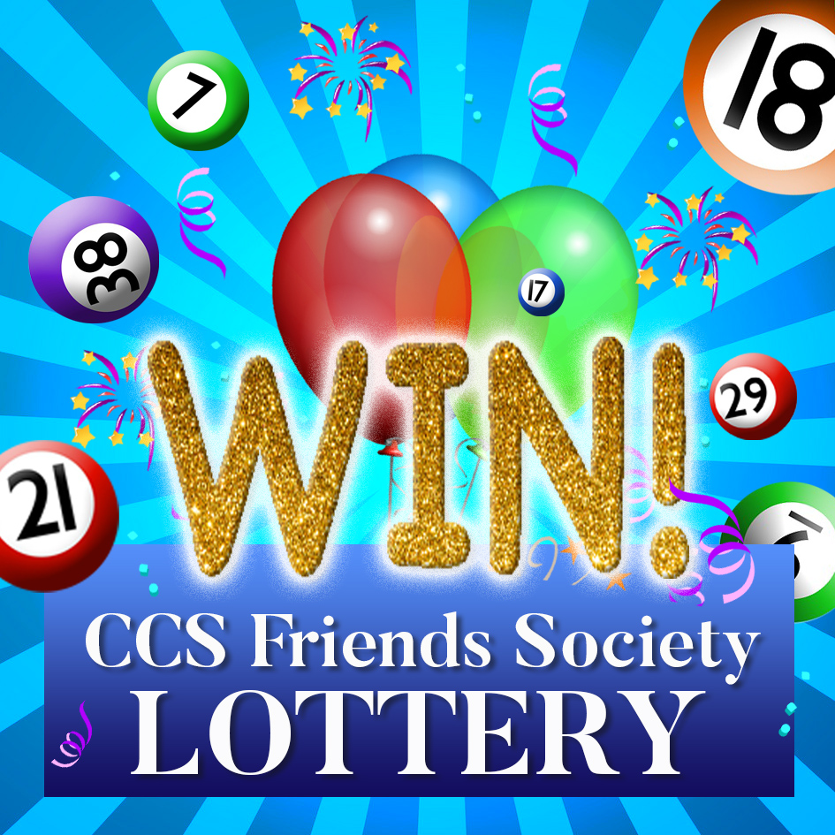

CCS FRIENDS PRIVATE SOCIETY LOTTERY –
APPLICATION FORM

Name:

Email Address:

Phone Number:

Date of birth (you must be over 16 to join):

Relationship to Caroline Chisholm School (i.e. parent/guardian /staff member):

_________________________________________________________________

Date you wish for your monthly subscription to commence*:

__________________________________________________________________

*Our lottery calendar year runs from September 2022 to August 2023.

I will be paying (please delete as appropriate):
£3 per month for monthly entry* OR £36 yearly subscription (one single payment)

*I understand that if my subscription is not paid by the 1st of the month I will not be entered into that month’s prize draw.

Please pay:
CAROLINE CHISHOLM SCHOOL FRIENDS ASSOCIATION
Recipients Sort Code: 23-05-80
Recipients Account Number: 44622335

Please state your surname as the reference.
PLEASE EMAIL THIS FORM TO: CCSFriends@protonmail.com

